27. Define a design in AEM (client library part 1)

Creating client library involves 4 steps as follows:

1. Define a design.

2. Creating client library.

3. Calling client library.

4. Assigning design to website.

Clientlibs are stored under /etc/designs

Tools -> Operations -> Configuration

Or can access <https://localhost:4502/miscadmin> directly to navigate to console for creating clientlibraries.

**Creating clientlibray:**

Navigate to <https://localhost:4502/miscadmin> and select Designs. Click on New -> Create page and provide details as mentioned below.

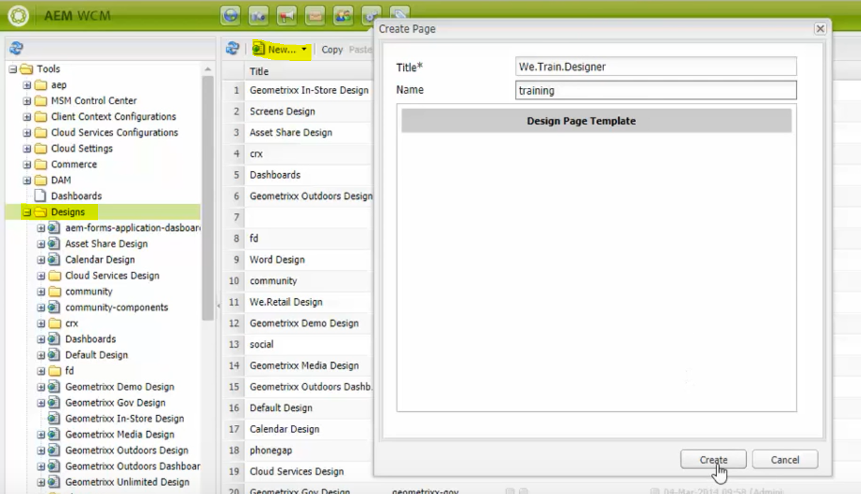

Design is the node of type cq:Page with its associated jcr:content child.